**File Permission Task**

**Create a file with .txt extension (/home/demo.txt). Change the permission set of that file, so that any user can read it, group can read/write & owner can read/write/execute it.**

Create a text file with .txt extension.

**Cmd: touch task2_file.txt**

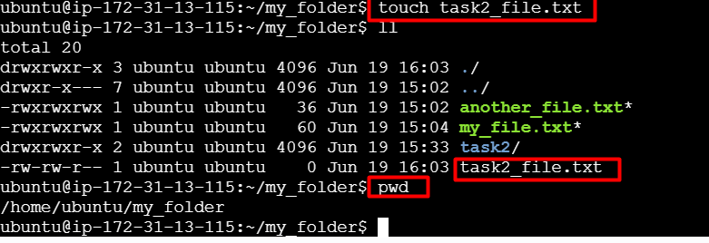

**Change the permissions of the created file.**   
 Rule 1: The owner can read/write/execute it.

Rule 2: The group can read/write

Rule 3: The user can read it

**Cmd: sudo chmod 764 task2_file.txt**

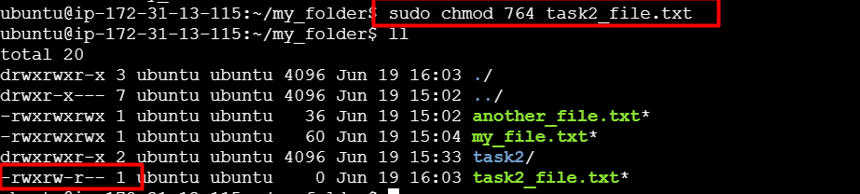

**Permission breakdown of 764:**

| **User Type** | **Permission** | **Explanation** |
| --- | --- | --- |
| Owner | 7 = rwx | Read, write, execute |
| Group | 6 = rw- | Read, write |
| Others | 4 = r-- | Read only |